
J
If you have a disability which requires special assistance for your participation in any of our 4-H activities, please contact the 4-H office so that preparations can be made.
2022-2023
Meeting Dates

Cameron Jr. Leader Club Registration Form
Return this portion of the brochure to:
Cameron 4-H Office
10098 Gulf Highway
Grand Lake LA 70607

Submit completed form and yearly dues of $20.00 are due by November 7, 2022.

Membership and participation are open to all Cameron Parish 4-Hers grades 8th – 12th.

Member Information
Name: _________________________________

Member Cell # _______________________

Member Email: _________________________________________

School: ________________________________

Grade: ____________ Age: _______________

T-Shirt Size: ____________

Parent
Email: _________________________________

Parent Cell # __________________________

4-Her’s Signature

Parent’s Signature

September 18
October 10

November 7
December 12
February 6
March 13
April 17

Monthly Meetings at 6:00 p.m.

Cameron Parish 4-H Office
10098 Gulf Highway
Grand Lake LA 70607
Phone: 337-905-1318
Brittany Zaunbrecher
bzaunbrecher@agcenter.lsu.edu

Cameron Parish



Junior Leaders

Junio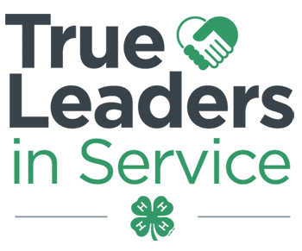r Leaders
PURPOSE

The purpose of the junior leadership is to teach youth the importance of understanding themselves as leaders and how to apply leadership skills in a team setting, and then assist them in identifying opportunities to practice leadership skills.
Junior Leaders learn the value of teamwork, goal setting, and decision making. These skills are put into action as 4-H Junior Leaders assist club leaders in club management and outreach activities.
A 4-H Junior Leader serves in the role of assisting other club members and the adult project club leader and as a mentor to younger 4-H members. An additional responsibility of a Cameron Parish Junior Leader is identifying and conducting local service-learning projects. Through active participation, junior leaders will interact with business, community and government leaders, educators, and extension staff to explore ways to contribute to the community.
EXPECTATIONS

- Set a good example through your own club work.
- Be interested in helping other 4-H members.
- Cooperatively work with your 4-H agents, adult leaders, parents, and other members.
- Plan your work and work your plan.
- Stay with the job until it is done.
- Respect others.
- Play fair, lose without complaining, and win without boasting.
REQUIREMENTS

- Enroll in Cameron Parish 4-H for the current year and pay dues.
- Be in grades 8th – 12th.
- If you cannot attend a meeting, call prior to the meeting to be excused.
- Actively participate and be a productive member in club planned Service-Learning projects.
- Complete as much of the 4-H Junior Leader Handbook as possible – Portfolio section.

TRIP REQUIREMENTS

Member must acquire 75% of total eligible points to attend trip. Member must also participate in all fundraisers.
- Officer Meeting – 2 points each
- Monthly Meeting – 5 points each
- Service Learning/Events – 10 points each
- Fundraisers – 10 points each



Leadership Team

2022-2023 Officers

President
Kaden Jackson
Vice President
Jolie Dupuie
Secretary
Julie Boenig
Reporter
Ariana Castillo
Treasurer
Delinda Landry
Parliamentarian
Luke Richard
Service-Learning Chairman
Kinsley Sibille

Be part of the team!

